Introduction:

Public transport optimization refers to the process of improving the efficiency, reliability, and sustainability of public transportation systems. It involves using various strategies, technologies, and data-driven approaches to make public transportation more convenient, cost-effective, and environmentally friendly. Here are some key aspects of public transport optimization:

Route Planning: Optimizing routes to ensure that public transport services cover high-demand areas and minimize travel time for passengers. This may involve adjusting bus or train routes, creating express routes, or introducing new services in underserved areas.

Scheduling: Developing efficient schedules that take into account factors like peak travel times, varying demand throughout the day, and the availability of vehicles and drivers. Real-time data and predictive analytics can help improve scheduling accuracy.

Frequency and Capacity: Adjusting the frequency of services based on demand to reduce passenger waiting times and avoid overcrowding. Dynamic capacity management systems can help allocate resources effectively.

Fare Structures: Evaluating fare structures to make public transport more affordable and attractive to riders while still covering operational costs. This may involve offering discounts, implementing smart card systems, or introducing distance-based pricing.

Integration: Promoting seamless integration between different modes of public transport (e.g., buses, trains, trams, subways) to create a comprehensive and interconnected transit network. This can make it easier for passengers to switch between modes and reduce travel times.

Technology Adoption: Embracing modern technologies like real-time tracking, digital payment systems, and smartphone apps to provide passengers with up-to-date information and streamline the ticketing process.

Sustainability: Implementing eco-friendly practices and technologies to reduce the environmental impact of public transportation, such as using electric or hybrid vehicles, improving energy efficiency, and promoting the use of bicycles and pedestrian-friendly infrastructure.

Data Analysis: Collecting and analyzing data on passenger behavior, travel patterns, and system performance to make informed decisions and continuously improve the public transport system.

Public Engagement: Involving the community and stakeholders in the decision-making process to ensure that public transport services meet the needs and expectations of the population.

Emergency and Contingency Planning: Developing plans and protocols to handle unexpected events such as natural disasters, strikes, or equipment failures to minimize service disruptions.

Public transport optimization can lead to a more reliable and attractive transportation system, which, in turn, can reduce traffic congestion, air pollution, and dependence on private vehicles, ultimately benefiting both urban environments and the people who rely on public transportation for their daily commutes.

Block diagram:

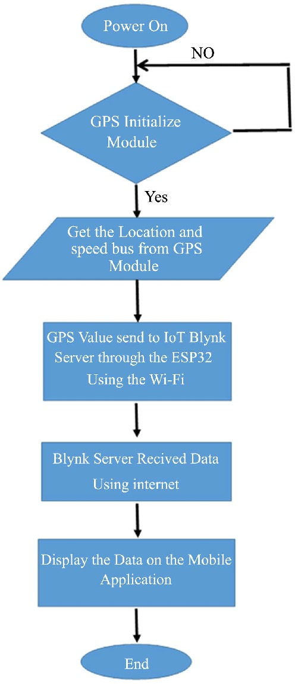

Practical example:

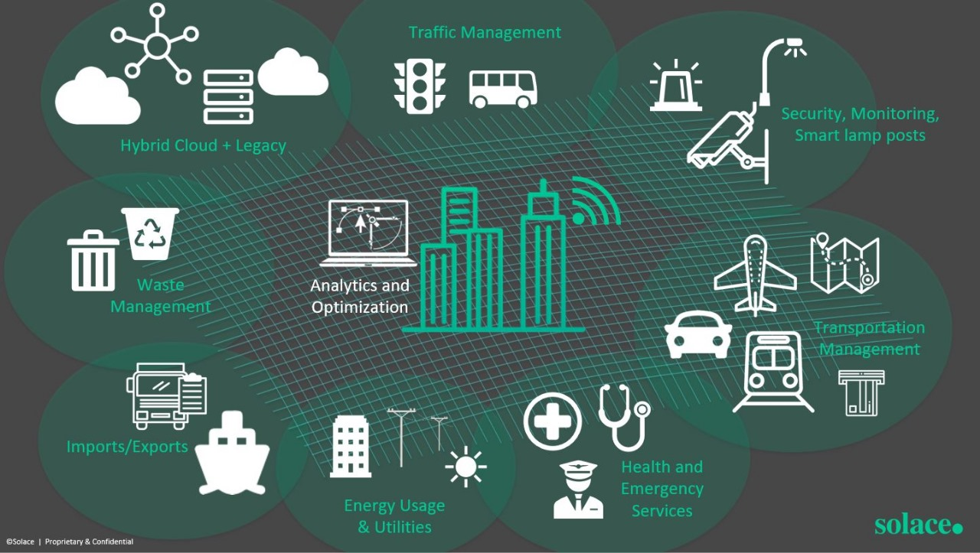

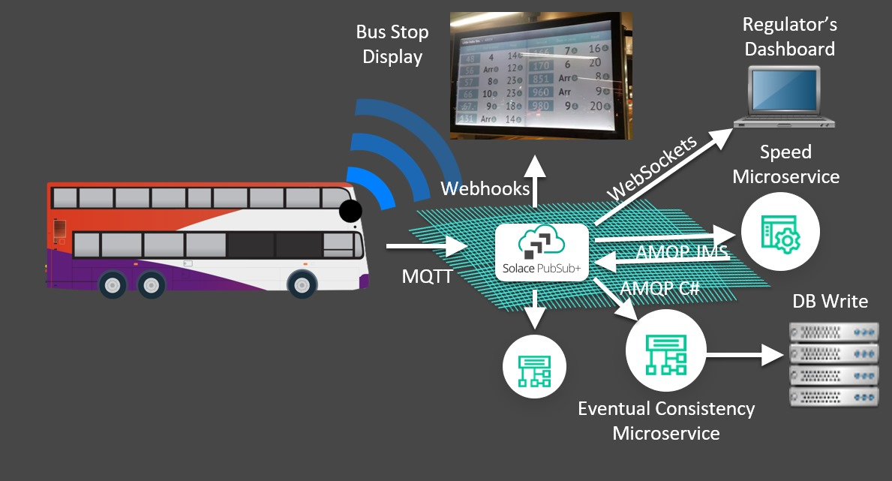

Concept:

Implement a Dynamic Demand-Responsive Transport (D-DRT) system that uses real-time data and predictive analytics to optimize public transport services. This system adapts routes, schedules, and capacity in response to changing passenger demand, traffic conditions, and other relevant factors.

Key Components and Features:

Real-Time Data Integration: Collect real-time data from various sources, including GPS trackers on vehicles, passenger mobile apps, and traffic sensors. Integrate this data into a centralized control system.

Predictive Analytics: Utilize machine learning algorithms to predict passenger demand patterns based on historical data, events, and external factors (e.g., weather, special events, holidays).

Dynamic Routing: The system continuously evaluates passenger demand and traffic conditions to adjust vehicle routes in real-time. This ensures that vehicles take the most efficient paths to serve passengers, minimizing travel times and congestion.

Flexible Scheduling: Instead of fixed schedules, the system dynamically schedules vehicles based on anticipated demand. Vehicles are dispatched as needed to meet passenger requests, reducing idle time and optimizing resource allocation.

Demand Forecasting: Predict future demand patterns and allocate resources accordingly. For example, during rush hours or major events, more vehicles can be deployed to high-demand areas.

Passenger-Facing App: Develop a user-friendly mobile app that allows passengers to request rides, track vehicle locations in real-time, and receive estimated arrival times. The app can also provide personalized trip recommendations based on passenger preferences and historical travel patterns.

Pricing Flexibility: Implement dynamic pricing based on demand, similar to ride-sharing services. Lower prices during off-peak hours can incentivize passengers to travel at less congested times.

Integration with Existing Transit: Ensure seamless integration with traditional public transport modes (e.g., buses, trains, subways) to facilitate transfers and provide a comprehensive transit network.

Environmental Sustainability: Use electric or hybrid vehicles in the D-DRT system to reduce emissions and promote sustainability.

Benefits:

Improved Efficiency: The D-DRT system optimizes resource allocation, reducing operational costs while improving service quality.

Reduced Congestion: By dynamically adapting routes and schedules, the system can help reduce traffic congestion and decrease travel times for passengers.

Enhanced User Experience: Passengers benefit from more convenient and personalized transportation options, leading to increased public transport usage.

Data-Driven Decision-Making: Public transport authorities can make data-driven decisions to continually optimize the system and respond to changing travel patterns.

Environmental Impact: Using electric or hybrid vehicles reduces greenhouse gas emissions and contributes to a more sustainable urban environment.

Implementing a Dynamic Demand-Responsive Transport system can significantly enhance the efficiency and attractiveness of public transportation, making it a more viable and appealing option for commuters while addressing urban transportation challenges.